Cincinnatus Central School
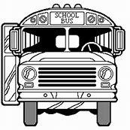
Cincinnatus, New York

Request for Transportation

Requesting Department ____________________________ Today’s Date _____________________

Activity or Event to be attended __________________________________________________________

Reason for Trip ________________________________________________________________________

Location (facility and city) _______________________________________________________________

Date transportation requested for _________________________________________________________

Departure time ________________ (cannot be 8 AM or before without consent of the Head Bus Driver)

Expected return time ____________

Number to transport ____________ (students) ___________ (chaperones)

Special requirements? (luggage rack, wheel chair, etc.) ________________________________________

Meal arrangements? ____________________________________________________________________

______________________________ ________________________________

Requestor’s Signature Building Principal’s Signature

_______________________________

Superintendent’s Signature (Required for overnight trips)

